### A CRM Application To Manage The Services Offered By An Institution.

**Description:**

A CRM application tailored for an institution like EduConsultPro Institute is designed to streamline the management of critical services such as admissions, student inquiries, and consulting requests. As the number of prospective students increases, managing these processes manually becomes inefficient and prone to errors. This CRM system provides a centralized platform where all student-related information is captured, stored, and managed, enabling the institution to automate application processes, track inquiries, and handle consulting services seamlessly. By automating key tasks such as application submissions, communication follow-ups, and appointment scheduling, the CRM enhances the overall experience for both students and staff. Additionally, it supports the management of immigration cases, ensuring that every interaction is handled with precision and care. Ultimately, this CRM solution allows EduConsultPro to focus on delivering high-quality education while ensuring that administrative processes are efficient, responsive, and student-centered.

Creating objects directly from a spreadsheet in Salesforce can be an efficient way to manage data. Here's a step-by-step guide to create a Course object using this method. You can use this guide to create a project document.

### *Create Course object*

#### Step 1: Access Salesforce

1. Log in to your Salesforce account.
2. Navigate to **Setup** by clicking on the gear icon in the top-right corner.

#### Step 2: Access Object Manager

1. In the **Setup** page, find the **Object Manager** tab at the top of the page and click on it.
2. Click on the **Create** button and choose **Create Object from Spreadsheet**.

#### Step 3: Download the Spreadsheet

1. **Click on the provided link to get the spreadsheet for the Course object.**
2. Save the spreadsheet to your local machine.

#### Step 4: Upload the Spreadsheet

1. In the **Create Object from Spreadsheet** window, click on the **Upload Your File** button.
2. Navigate to where you saved the Course spreadsheet and select it.

#### Step 5: Map Fields

1. Once the spreadsheet is uploaded, Salesforce will automatically try to map the fields from the spreadsheet to the object fields.
2. Review the field mappings to ensure that they align correctly with the columns in your spreadsheet.
3. Adjust any mappings if necessary by clicking on the dropdowns and selecting the correct field.

#### Step 6: Create the Object

1. After mapping, click on the **Next** button.
2. Review the object details and field mappings again.
3. Click **Create** to finish the process.

#### Step 7: Verify the New Object

1. Once the object is created, navigate back to the **Object Manager**.
2. Search for the new **Course** object and click on it to review the fields, relationships, and other settings.

#### Step 8: Test the Object

1. Navigate to the **App Launcher** (the grid icon in the top-left corner) and search for **Courses**.
2. Create a new Course record to ensure that everything is working correctly.

### *Create Remaining objects*

#### Step 1: Access Salesforce

1. **Log in** to your Salesforce account.
2. Navigate to **Setup** by clicking on the gear icon in the top-right corner.

#### Step 2: Access Object Manager

1. In the **Setup** page, find the **Object Manager** tab at the top of the page and click on it.
2. Click on the **Create** button and select **Create Object from Spreadsheet**.

#### Step 3: Download the Spreadsheet

1. Click on the provided link to download the spreadsheet for the object you want to create.
   1. **Consultant** Spreadsheet
   2. **Student** Spreadsheet
   3. **Appointment** Spreadsheet
2. Save the spreadsheet to your local machine.

#### Step 4: Upload the Spreadsheet

1. In the **Create Object from Spreadsheet** window, click on the **Upload Your File** button.
2. Navigate to the location where you saved the spreadsheet and select it.

#### Step 5: Map Fields

1. After the spreadsheet is uploaded, Salesforce will automatically map the fields.
2. **Review the field mappings** to ensure they align correctly with the columns in your spreadsheet.
3. If necessary, adjust any mappings by clicking on the dropdowns and selecting the correct field.

#### Step 6: Create the Object

1. Once you’ve reviewed the field mappings, click **Next**.
2. **Review the object details** and mappings one last time.
3. Click **Create** to complete the process.

#### Step 7: Verify the New Object

1. After creating the object, navigate back to the **Object Manager**.
2. Search for the newly created **Consultant**, **Student**, or **Appointment** object, and click on it to review the fields, relationships, and other settings.

#### Step 8: Test the Object

1. Navigate to the **App Launcher** (the grid icon in the top-left corner) and search for the object you created.
2. **Create a new record** to ensure that everything is functioning correctly.

### *Create Relationship among the objects*

#### Task 1: Creating Lookup Relationships

**1. Create Lookup Relationship between Appointment and Student**

1. **Access Salesforce:**
   1. Log in to your Salesforce account.
   2. Go to **Setup** by clicking on the gear icon in the top-right corner.
2. **Navigate to Object Manager:**
   1. In the **Setup** page, click on the **Object Manager** tab.
   2. Search for and select the **Appointment** object.
3. **Add Lookup Relationship:**
   1. Within the **Appointment** object, go to the **Fields & Relationships** section.
   2. Click **New** to create a new field.
   3. Choose **Lookup Relationship** as the data type, then click **Next**.
   4. In the **Related To** dropdown, selec
   5. t **Student**.
   6. Click **Next**, configure the relationship settings, and click **Save**.

**2. Create Lookup Relationship between Appointment and Consultant**

1. **Navigate to Object Manager:**
   1. Search for and select the **Appointment** object (if not already selected).
2. **Add Lookup Relationship:**
   1. Within the **Appointment** object, go to the **Fields & Relationships** section.
   2. Click **New** to create a new field.
   3. Choose **Lookup Relationship** as the data type, then click **Next**.
   4. In the **Related To** dropdown, select **Consultant**.
   5. Click **Next**, configure the relationship settings, and click **Save**.

**3. Create Lookup Relationship between Student and Case**

1. **Navigate to Object Manager:**
   1. Search for and select the **Student** object.
2. **Add Lookup Relationship:**
   1. Within the **Student** object, go to the **Fields & Relationships** section.
   2. Click **New** to create a new field.
   3. Choose **Lookup Relationship** as the data type, then click **Next**.
   4. In the **Related To** dropdown, select **Case**.
   5. Click **Next**, configure the relationship settings, and click **Save**.

#### Task 2: Creating the Registration Object

**1. Create the Registration Object**

1. **Navigate to Object Manager:**
   1. Go to **Setup** and click on the **Object Manager** tab.
   2. Click **Create** and select **Custom Object**.
2. **Define Object Details:**
   1. In the **Label** field, enter **Registration**.
   2. The **Plural Label** will be automatically populated as **Registrations**.
   3. Enter an **Object Name** (API name), such as **Registration**.
   4. Set **Record Name** as **Auto Number** or **Text**, depending on your preference.
   5. Click **Save**.

**2. Add Fields to the Registration Object**

1. **Add Lookup Relationship to Student:**
   1. Within the **Registration** object, go to the **Fields & Relationships** section.
   2. Click **New**, select **Lookup Relationship**, and click **Next**.
   3. In the **Related To** dropdown, select **Student**.
   4. Click **Next**, configure the relationship settings, and click **Save**.
2. **Add Lookup Relationship to Course:**
   1. Repeat the same steps as above, but in the **Related To** dropdown, select **Course**.
   2. Click **Next**, configure the relationship settings, and click **Save**.
3. **Add Additional Fields:**
   1. Click **New** to create additional fields as required (e.g., **Registration Date**, **Status**).
   2. Select the appropriate data types, configure settings, and click **Save** after each field.

#### Task 3: Creating Tabs for the Respective Objects

**1. Create Tabs for Custom Objects**

1. **Access Tabs Setup:**
   1. Go to **Setup** and in the **Quick Find** box, type **Tabs**.
   2. Select **Tabs** under the **User Interface** section.
2. **Create New Tab:**
   1. Click **New** in the **Custom Object Tabs** section.
   2. In the **Object** dropdown, select the object (e.g., **Consultant**, **Student**, **Appointment**, **Registration**).
   3. Choose a **Tab Style** by clicking the lookup icon and selecting an icon.
   4. Click **Next**, assign to appropriate profiles, and click **Save**.
3. **Repeat for All Custom Objects:**
   1. Repeat the steps above to create tabs for **Consultant**, **Student**, **Appointment**, and **Registration**.

### *Configure the Case Object*

### 1. Log In to Salesforce

1. Log in to your Salesforce account with the appropriate permissions to make changes to object settings.

### 2. Access Object Manager

1. From the Salesforce home page, click on the **"App Launcher"** (the grid icon) in the top-left corner.
2. Type and select **"Object Manager"**.

### 3. Locate the Case Object

1. In the Object Manager, you will see a list of objects. Use the search bar or scroll through the list to find **"Case"**.
2. Click on **"Case"** to open its settings.

### 4. Edit the Case Object Fields

1. In the Case object settings, navigate to the **"Fields & Relationships"** tab on the left-hand side.

### 5. Configure the "Type" Field

1. Scroll through the list or use the search bar to find **"Type"**.
2. Click on **"Type"** to open the field settings.
3. In the Type field settings, click on **"New"** to add new values.
4. Enter **"Immigration"** and **"Visa Application"** as new picklist values. Click **"Save"** after adding each value.

### 6. Configure the "Status" Field

1. Return to the **"Fields & Relationships"** tab.
2. Locate and click on the **"Status"** field.
3. Click on **"New"** to add new picklist values.
4. Enter **"Open"** and **"In-progress"** as new values. Click **"Save"** after adding each value.

### 7. Verify the Changes

1. After saving the new values, you might want to verify that they have been added correctly.
2. Go back to the **"Case"** object and check the picklist values for the **"Type"** and **"Status"** fields to ensure that your new values appear as expected.

### 8. Update Page Layouts (if necessary)

1. If you need the new values to be visible on specific page layouts, navigate to the **"Page Layouts"** section under the Case object.
2. Edit the relevant page layouts and ensure the **"Type"** and **"Status"** fields are included as needed.

### 9. Test the Configuration

1. Create a new case or edit an existing one to ensure that the new picklist values are available and functioning as expected.

### *Create a Lightning App*

### 1. Log In to Salesforce

1. Log in to your Salesforce account with administrative privileges.

### 2. Access App Manager

1. Click on the **"Gear"** icon in the top-right corner of the screen to open the Setup menu.
2. In the **Quick Find** box on the left, type **"App Manager"** and select **"App Manager"** from the dropdown list.

### 3. Create a New Lightning App

1. In the App Manager, click the **"New Lightning App"** button.

### 4. Set Up Basic App Information

1. **App Name**: Enter **"EduConsultPro"**.
2. **App Name (Plural)**: This will auto-fill based on the app name you entered.
3. **Description**: Optionally, you can enter a description for the app.
4. Click **"Next"**.

### 5. Configure App Branding

1. You can set up branding by choosing an app logo and selecting a color scheme. If you don't need any branding changes, you can skip this step.
2. Click **"Next"**.

### 6. Configure App Navigation

1. **Select Items**:
   1. From the **"Available Items"** section, find and select the following tabs: **Home, Students, Courses, Consultants, Appointments, Registrations, and Cases**.
   2. Move them to the **"Selected Items"** list by clicking the right arrow button.
2. Click **"Next"**.

### 7. Configure App Visibility

1. **Available Profiles**:
   1. Find **"System Administrator"** in the list of available profiles and move it to the **"Selected Profiles"** list.
2. Click **"Save & Finish"**.

### 8. Verify and Access Your New App

1. After saving, you should see **EduConsultPro** in your App Manager list.

You can click **"App Launcher"** (the grid icon) and select **EduConsultPro** to view and test the app.

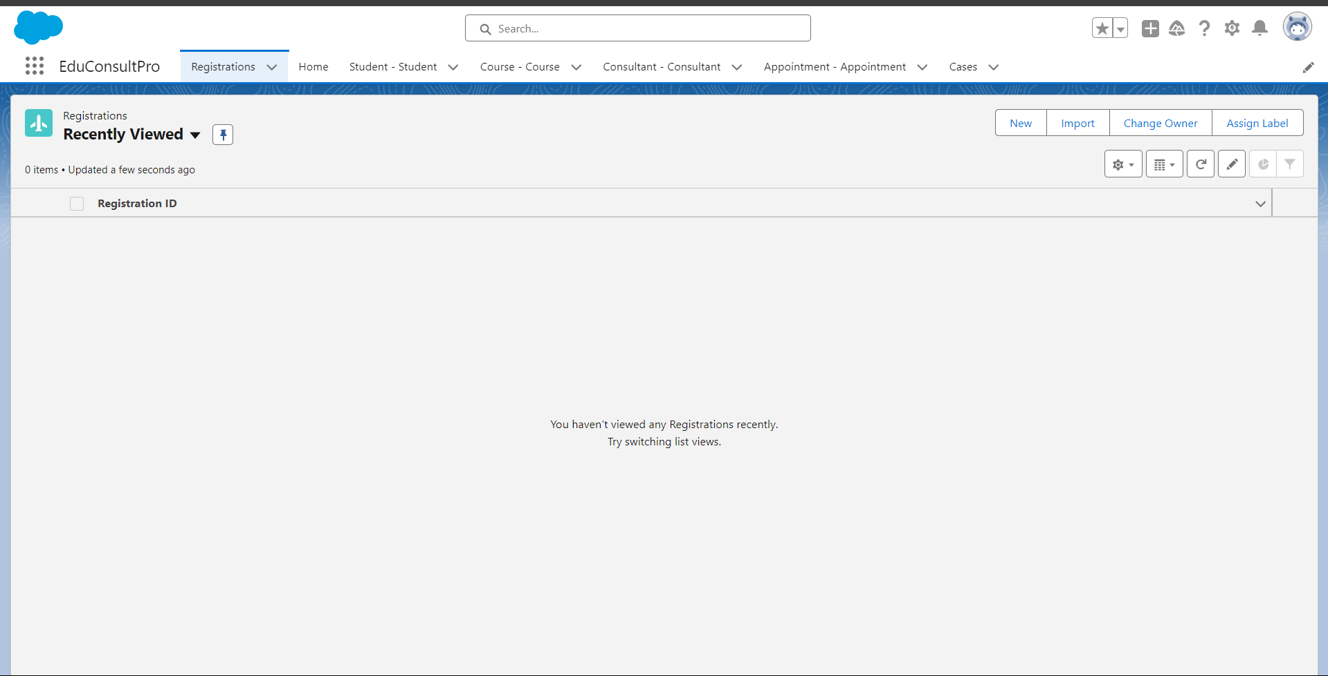

### *Create a Screen Flow for Student Admission Application process.*

### Add Screen Element

### 1. Log In to Salesforce

1. Log in to your Salesforce account with the necessary permissions to create and modify Flows.

### 2. Access Flow Builder

1. Click on the **"Gear"** icon in the top-right corner of the screen to open the Setup menu.
2. In the **Quick Find** box on the left, type **"Flow Builder"** and select **"Flow Builder"** from the dropdown list.

### 3. Create a New Flow

1. In Flow Builder, click **"New Flow"**.
2. Select **"Screen Flow"** and click **"Create"**.

### 4. Add a Screen Element

1. In the Flow Builder canvas, you’ll see a variety of elements on the left side.
2. Drag the **"Screen"** element from the **"Elements"** tab onto the canvas.

### 5. Configure the Screen Element

1. **Label**: In the Screen Properties pane on the right, set the **Label** to **"Student Info"**. This is the name that will appear on the screen.
2. **API Name**: This auto-populates based on the label but can be customized if needed.

### 6. Add Fields to the Screen

1. Click on **"Fields"** in the Screen Properties pane.
2. **Record Variable Input**: Click on **"Record Variable Input"**. This allows you to create a variable to fetch and display fields from a specific object.

#### Create a New Resource for the Student Object

1. Click on **"New Resource"**.
   1. **Resource Type**: Select **"Variable"**.
   2. **API Name**: Enter **"StudentRecordRes"**.
   3. **Data Type**: Choose **"Record"**.
   4. **Object**: Select **"Student"** (or the object where student information is stored).
   5. **Allow input**: Check the box for **"Available for input"** if you want to pass this variable into the flow from another source.
   6. Click **"Done"**.

### 7. Add Fields from the Student Object

1. With **"StudentRecordRes"** selected, you will see all the fields from the Student object in the **"Fields"** pane.
2. Drag and drop the required fields onto the screen element in the Flow Builder canvas. For example, you might add fields like **Name, Email, Phone Number**, etc.

### 8. Save and Activate the Flow

1. Click **"Save"** to save your progress. Enter a **Name** and **Description** for the flow if prompted.
2. To make the flow available for use, click **"Activate"**.

### 9. Test the Flow

1. After activation, you can test the flow by running it. Ensure that the **"Student Info"** screen displays all the fields correctly and allows you to input student information.

You have now successfully added a Screen element to your Flow and configured it to display fields from the Student object.

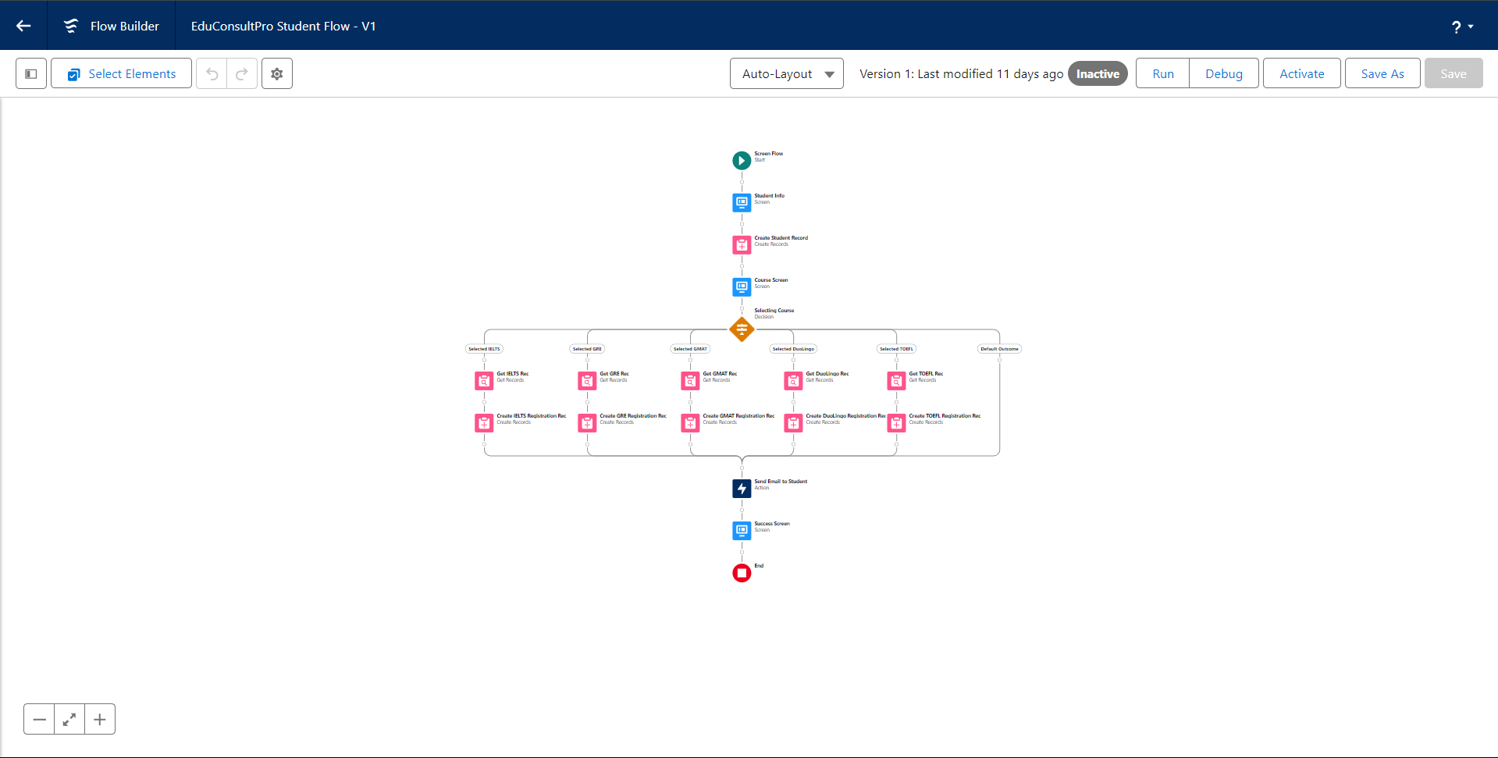

### *Create Student Record using Create Element*

### Open Flow Builder

1. Ensure you are still in the Flow Builder where you previously added the “Student Info” Screen element. If not, navigate to **Flow Builder** from the Salesforce Setup menu and open the flow you’re working on.

### 2. Add a Create Record Element

1. From the **Elements** tab on the left side of the Flow Builder canvas, drag the **"Create Records"** element onto the canvas, placing it right after the “Student Info” Screen element.

### 3. Configure the Create Records Element

1. **Label**: In the Create Records Properties pane on the right, enter **"Create Student Record"** as the label for this element.
2. **How Many Records to Create**:
   1. Select **"One"**. This indicates that the flow will create a single record.
3. **How to Set the Record Fields**:
   1. Select **"Use all values from a record"**. This means the flow will use the values from the record variable to populate the fields of the new record.
4. **Record Variable**:
   1. Under **"Create a record from these values"**, you’ll need to select the record variable resource you created earlier.
   2. Select **"StudentRecordRes"** from the dropdown list. This will ensure that the flow uses the data captured in the Student Info screen to create a new record.

### 4. Define the Object to Create

1. **Object**: In the **"Create Records"** element, select **"Student"** (or the relevant object name where the student information is to be stored).

### 5. Connect the Elements

1. Connect the **"Student Info"** Screen element to the **"Create Student Record"** element by dragging the node from the Screen element to the Create Records element.

### 6. Save and Activate the Flow

1. Click **"Save"** to save your changes. Provide a **Name** and **Description** for the flow if prompted.
2. Click **"Activate"** to make the flow available for use.

### 7. Test the Flow

1. Run the flow to ensure that it correctly creates a Student record with the information inputted on the “Student Info” screen. Verify that the record is created in Salesforce as expected.

### . Add the Course Screen Element

1. **Open Flow Builder**: Ensure you're in the Flow Builder for your flow.
2. **Add a Screen Element**:
   1. Drag the **"Screen"** element from the left side panel onto the canvas after the “Create Student Record” element.
   2. **Label**: Enter **"Course Screen"**.
3. **Add Picklist Components**:
   1. Drag a **"Picklist"** component from the left side panel onto the screen.
   2. **Label**: Enter **"Select Course"**.
   3. **Choices**:
      1. Click **"Add Choice"** and enter **"IELTS"**, then click **"Done"**.
      2. Repeat for **"GRE"**, **"GMAT"**, **"Duolingo"**, and **"TOEFL"**. Each choice will create a variable for each option.

### 2. Add the Decision Element

1. **Add a Decision Element**:
   1. Drag the **"Decision"** element from the left side panel onto the canvas, placing it after the “Course Screen” element.
   2. **Label**: Enter **"Selecting Course"**.
2. **Configure Decision Outcomes**:
   1. Click **"Add Outcome"** and enter **"Selected IELTS"**.
   2. **Resource**: Select **"Select_Course"** (the picklist component from the Course Screen).
   3. **Operator**: Choose **"Equals"**.
   4. **Value**: Enter **"IELTS"**.
3. **Repeat for Other Options**:
   1. Click on the **“+”** icon to add more outcomes.
   2. Add outcomes for **"Selected GRE"**, **"Selected GMAT"**, **"Selected DuoLingo"**, and **"Selected TOEFL"**.
   3. For each, set the resource to **"Select_Course"**, operator to **"Equals"**, and value to the respective course option.

### 3. Create Registration Record

1. **Add Create Records Element**:
   1. Drag the **"Create Records"** element onto the canvas, placing it after the decision outcomes.
   2. **Label**: Enter **"Create IELTS Registration Rec"**.
2. **Configure the Create Records Element**:
   1. **How Many Records to Create**: Select **"One"**.
   2. **How to Set the Record Fields**: Choose **"Use separate resources, and literal values"**.
   3. **Object**: Select **"Registration"**.
3. **Set Field Values**:
   1. **Field**: Course_Name__c
      1. **Value**: {!Get_IELTS_Rec.Id}
   2. **Field**: Student_Name__c
      1. **Value**: {!StudentRecordRes.Id}
4. **Repeat for Other Courses**:
   1. Repeat the steps to create records for GRE, GMAT, TOEFL, and DuoLingo, with respective labels such as **"Create GRE Registration Rec"**, **"Create GMAT Registration Rec"**, etc.

### 4. Create Email Text Templates

1. **Create Email Body Template**:
   1. Click the **toggle toolbox** on the left corner and select **"New Resource"**.
   2. **Resource Type**: Choose **"Text Template"**.
   3. **API Name**: Enter **"StuRegistrationEmailTextTempBody"**.
   4. **Format**: Select **"View as plain text"**.
   5. **Body**: Paste the provided email body text.
   6. Click **"Done"**.
2. **Create Email Subject Template**:
   1. Repeat the steps to create another text template.
   2. **API Name**: Enter **"StuRegistrationEmailTextTempSub"**.
   3. **Body**: Enter your email subject text.
   4. Click **"Done"**.

### 5. Add Action Element for Sending Email

1. **Add Action Element**:
   1. Drag the **"Action"** element onto the canvas after all decision paths.
   2. **Label**: Enter **"Send Email to Student"**.
2. **Configure Action**:
   1. **Action Type**: Choose **"Send Email"**.
   2. **Set Input Values**:
      1. **Body**: {!StuRegistrationEmailTextTempBody}
      2. **Recipient Address List**: {!StudentRecordRes.Email__c}
      3. **Subject**: {!StuRegistrationEmailTextTempSub}

### 6. Add Success Screen Element

1. **Add a Screen Element**:
   1. Drag the **"Screen"** element onto the canvas after the “Send Email to Student” action.
   2. **Label**: Enter **"Success Screen"**.
2. **Add Display Text Component**:
   1. Drag the **"Display Text"** component from the left side panel onto the screen.
   2. **Label**: Enter **"SuccessMessage"**.
   3. **Text**: Paste the provided success message text.

### 7. Finalize and Save the Flow

1. **Connect the Elements**:
   1. Ensure all elements are connected appropriately:
      1. **Student Info Screen** ➔ **Create Student Record**
      2. **Create Student Record** ➔ **Course Screen**
      3. **Course Screen** ➔ **Selecting Course** (Decision)
      4. **Selecting Course** outcomes ➔ respective **Create Records** elements
      5. **Create Records** elements ➔ **Send Email to Student**
      6. **Send Email to Student** ➔ **Success Screen**
2. **Save the Flow**:
   1. Click **"Save"**.
   2. **Flow Name**: Enter **"EduConsultPro Student Flow"**.
   3. Click **"Save"**.
3. **Activate the Flow**:
   1. After saving, click **"Activate"** to make the flow available for use.

### *Create Users*

### Create a User with Standard Platform User Profile

1. **Log In to Salesforce**
   1. Log in to your Salesforce account with administrative privileges.
2. **Navigate to User Creation**
   1. Click on the **"Gear"** icon in the top-right corner to open the Setup menu.
   2. In the **Quick Find** box, type **"Users"** and select **"Users"** from the dropdown.
3. **Create a New User**
   1. Click the **"New User"** button.
4. **Fill in User Details**
   1. **Last Name**: Enter **"Consultant"**.
   2. **License**: Select **"Salesforce Platform"** from the dropdown list.
   3. **Profile**: Choose **"Standard Platform User"** from the dropdown list.
   4. **Fill Mandatory Fields**:
      1. Complete all required fields, such as **First Name**, **Username**, **Email**, **Alias**, **Role**, **User License**, and **Profile**.
      2. Ensure you set a unique **Username** (usually in the format of an email address).
5. **Save the User**
   1. After filling out all mandatory fields, click **"Save"** to create the user.

### Configure the User Settings

1. **Navigate to User Settings**
   1. In the Setup menu, click on **"Users"** to access the user list.
   2. Locate the newly created user (Consultant) and click **"Edit"** next to their name.
2. **Update Approver Settings**
   1. Scroll down to the **"Approver Settings"** section.
   2. In the **"Manager"** field, select **"Consultant"** from the dropdown list. (Ensure that "Consultant" is a user already created and assigned to the role you want.)
3. **Save the Changes**
   1. Click **"Save"** to apply the changes to the user’s settings.

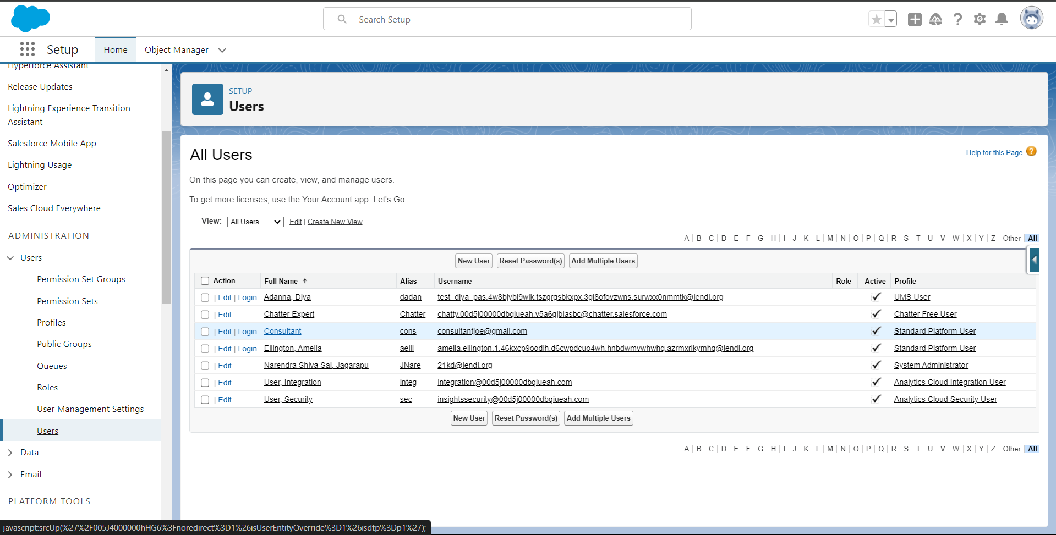

### *Create an Approval Process for Property Object*

### Create Email Templates

#### Enable Lightning Email Templates

1. **Navigate to Email Templates Settings**:
   1. From Setup, enter **"Templates"** in the Quick Find box.
   2. Select **"Lightning Email Templates"** and ensure it is toggled on.

#### Create a Folder for Email Templates

1. **Open App Launcher**:
   1. Click on the **App Launcher** (grid icon) in the top-left corner of Salesforce.
   2. Search for **"Email Templates"** and select it.
2. **Create a New Folder**:
   1. Click **"New Folder"**.
   2. Enter a desired name for the folder (e.g., **"Appointment Email Templates"**).
   3. Click **"Save"**.

#### Create the Submission Template

1. **Open Email Templates**:
   1. Still within the **Email Templates** app, click **"New Email Template"**.
2. **Configure the Email Template**:
   1. **Folder**: Select the folder you created (e.g., **"Appointment Email Templates"**).
   2. **Email Template Name**: Enter **"Submission Template"**.
   3. **Subject**: Enter a relevant subject for the email (e.g., **"Appointment Confirmation"**).

#### Create Approval and Rejection Templates

1. **Create the Approval Template**:
   1. Repeat the steps above to create a new email template.
   2. **Name**: **"Approval Template"**.
   3. **HTML Value**: Customize the message to confirm the approval of the request.
2. **Create the Rejection Template**:
   1. Repeat the steps to create another email template.
   2. **Name**: **"Rejection Template"**.
   3. **HTML Value**: Customize the message to notify the user of the rejection.

### 2. Create an Approval Process

1. **Navigate to Approval Processes**:
   1. From Setup, enter **"Approval Processes"** in the Quick Find box and select it.
2. **Create a New Approval Process**:
   1. **Manage Approval Processes For**: Select **"Appointment"**.
   2. Click **"Create New Approval Process"**.
   3. Select **"Use Jump Start Wizard"** and click **"Next"**.
3. **Configure the Approval Process**:
   1. **Process Name**: Enter **"Appointment Approval"**.
   2. **Under Select Approver**: Choose **"Manager"** for the option **“Automatically assign an approver using a standard or custom hierarchy field”**.
4. **Set Approver Settings**:
   1. **Automated Approver Determined By**: Select **"Manager"**.
5. **Record Editability Properties**:
   1. **Click on**: Choose **"Administrators OR the currently assigned approver can edit records during the approval process"**.
6. **Save the Approval Process**:
   1. Click **"Save"** to create the process.
7. **Configure Initial Submission Actions**:
   1. Click on **"View Approval Process Detail Page"**.
   2. **Initial Submission Actions**:
      1. **Add New**: Click **"Field Update"** and configure it (you will need to set specific field update values based on your requirements).
      2. **Add New**: Click **"Email Alert"**.
         1. **Description**: Enter **"Submission Email Alert"**.
         2. **Email Template**: Choose **"Submission Template"**.
         3. **Recipient Type**: Select **"Select your Name"** (or any desired recipient).
8. **Configure Final Approval and Rejection Actions**:
   1. Repeat steps 7a and 7b for **Final Approval** and **Final Rejection** actions.
   2. **Email Templates**: Select the **"Approval Template"** for Final Approval and **"Rejection Template"** for Final Rejection.

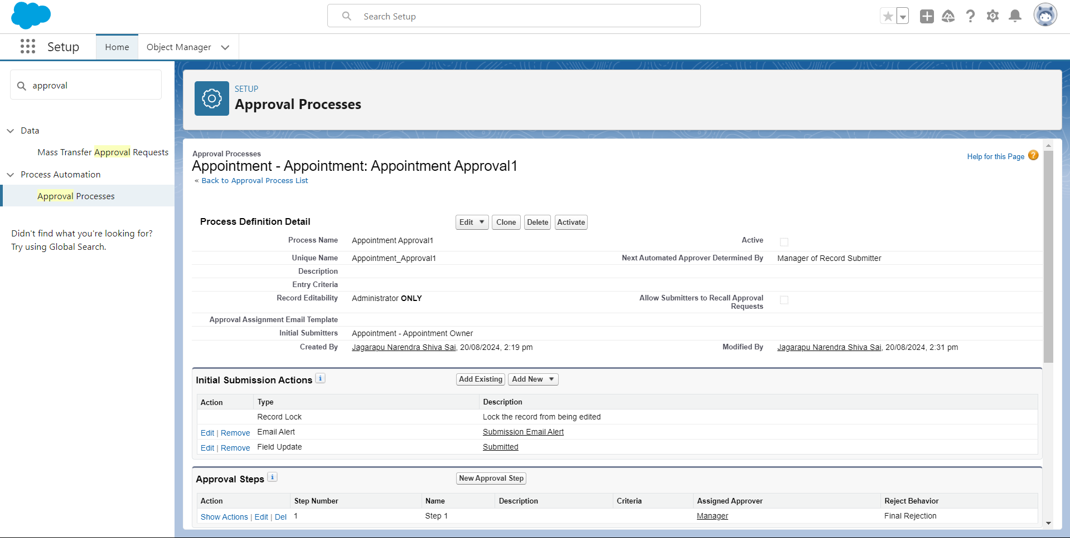

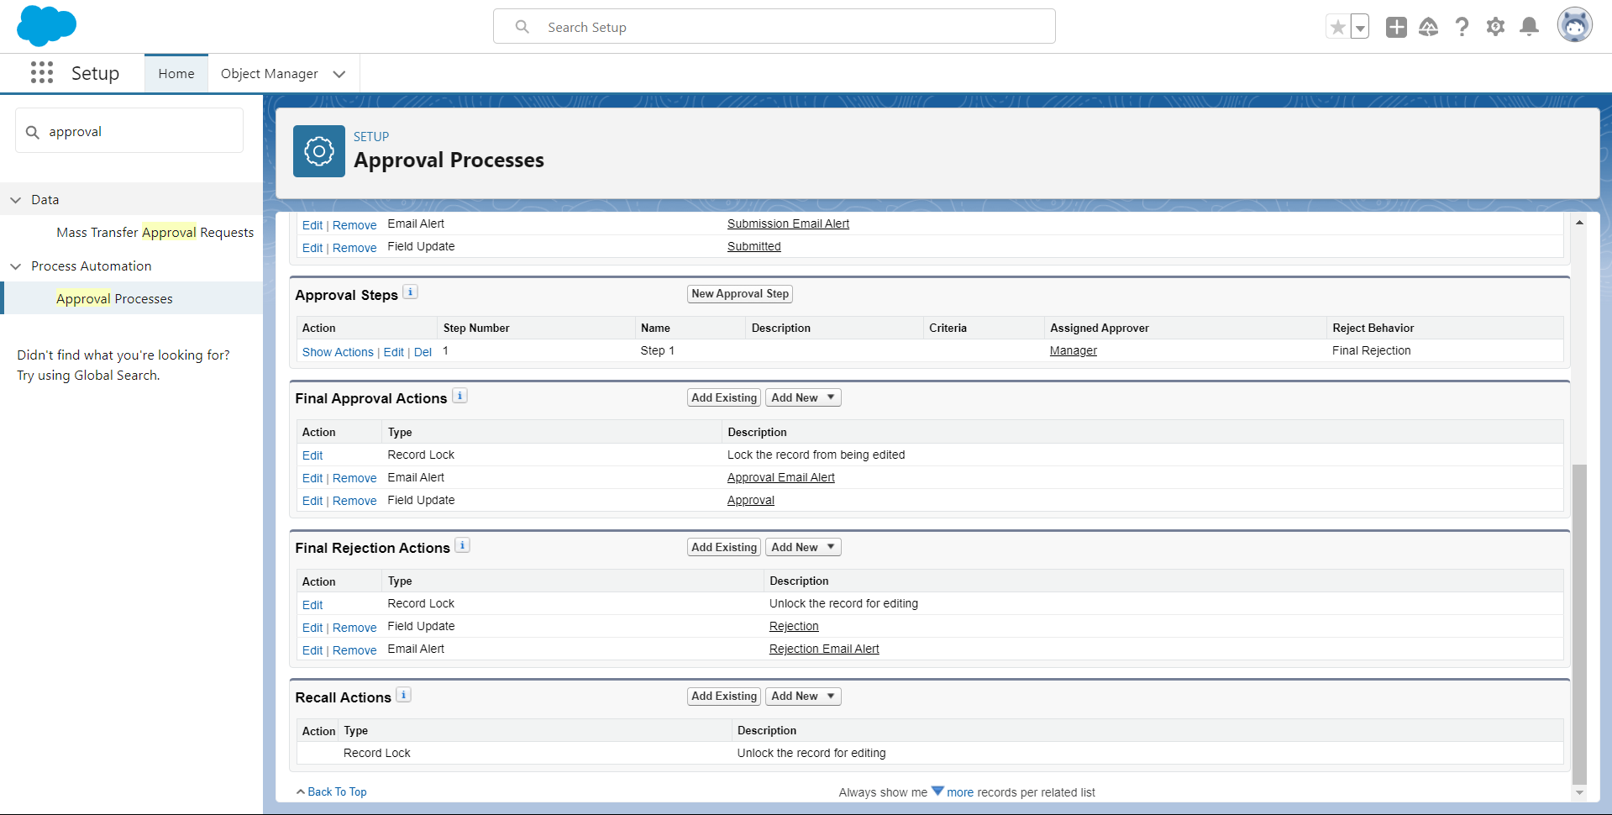

***Create a Record Triggered Flow***

### Configure the Start Element

1. **Log In to Salesforce**
   1. Log in to your Salesforce account with the necessary administrative permissions.
2. **Navigate to Flow Setup**
   1. Click on the **"Gear"** icon in the top-right corner to open the Setup menu.
   2. In the **Quick Find** box, type **"Flows"** and select **"Flows"** from the dropdown.
3. **Create a New Flow**
   1. Click on **"New Flow"**.
   2. Select **"Record-Triggered Flow"** from the options.
   3. Click **"Create"** to open the Configure Start window.
4. **Configure the Start Element**
   1. **Object**: Choose **"Appointment"** from the dropdown list. This specifies that the flow will be triggered by changes to records in the Appointment object.
   2. **Trigger the Flow When**: Select **"A record is created"**. This means the flow will start when a new Appointment record is created.
5. The flow should look like this:

### Add an Action Element

1. **Add an Action Element**
   1. Drag the **"Action"** element from the left side panel onto the flow canvas, placing it after the Start element.
2. **Configure the Action Element**
   1. **Label**: Enter **"Approval SubFlow"**.
   2. **Action Type**: Select **"Submit for Approval"** from the list of actions.
3. **Set the Record ID**
   1. **Record ID**: Enter {!$Record.Id}. This binds the action to the ID of the record that triggered the flow, ensuring that the flow submits the specific record for approval.

### Save and Activate the Flow

1. **Save the Flow**
   1. Click **"Save"** in the top-right corner of the Flow Builder.
   2. **Flow Name**: Enter **"EduConsultPro Approval Flow"** as the label.
   3. Add a description if needed for clarity.
   4. Click **"Save"**.
2. **Activate the Flow**
   1. Click **"Activate"** to make the flow live. This ensures that the flow will trigger when a new Appointment record is created.

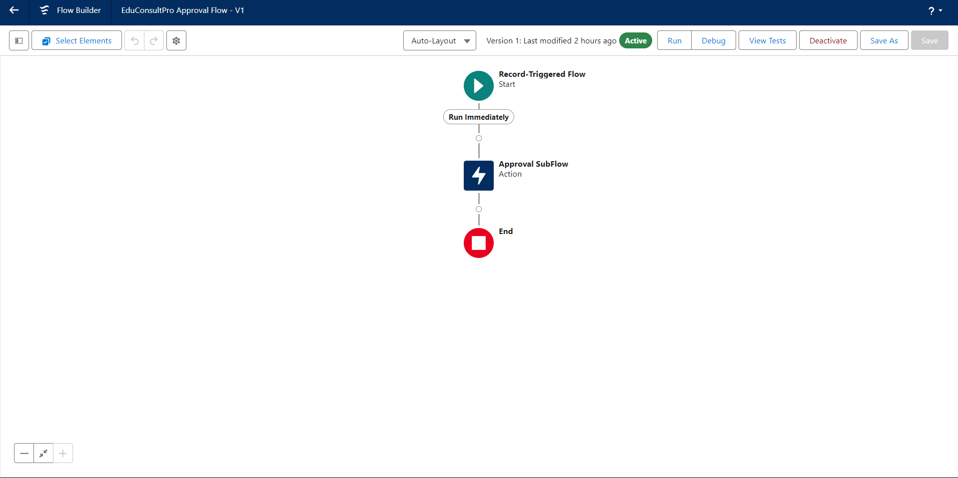

### *Create a ScreenFlow for Existing Student to Book an Appointment*

### 1. Create a New Screen Flow

1. **Log In to Salesforce**:
   1. Log in with administrative privileges.
2. **Navigate to Flow Builder**:
   1. Go to **Setup**.
   2. In the **Quick Find** box, type **"Flow Builder"** and select it.
   3. Click **"New Flow"**.
   4. Select **"Screen Flow"** and click **"Create"**.

### 2. Add a Screen Element to Get Student Info

1. **Add Screen Element**:
   1. Drag a **"Screen"** element from the left-side panel onto the flow canvas.
2. **Configure Screen Properties**:
   1. **Label**: Enter **"Get Student Info"**.
3. **Add Text Components**:
   1. Drag and drop **"Text"** components from the left-side panel to the screen element.
   2. **First Text Component**:
      1. **Label**: Enter **"Enter Student Name"**.
   3. **Second Text Component**:
      1. **Label**: Enter **"Enter Student Email"**.
4. **Click Done** to save the screen element.

### 3. Add GET Record Element to Retrieve Student Record

1. **Add GET Record Element**:
   1. Drag a **"Get Records"** element from the left-side panel onto the canvas, placing it after the Decision element on the IELTS path.
   2. **Label**: Enter **"Get Rec"**.
2. **Configure GET Records**:
   1. **Object**: Select **"Student"**.
   2. **Condition Requirements**: Select **"All Conditions are Met (AND)"**.
   3. **Field Conditions**:
      1. **Field**: Student Name
         1. **Operator**: Equals
         2. **Value**: {!Enter_Student_Name}
      2. **Field**: Email__c
         1. **Operator**: Equals
         2. **Value**: {!Enter_Student_Email}
3. **Click Done** to save the GET Record element.

### 4. Add Decision Element for Appointment or Case

1. **Add Decision Element**:
   1. Drag a **"Decision"** element from the left-side panel onto the canvas, placing it after the "Display Student Details" element.
   2. **Label**: Enter **"Appointment or Case"**.
2. **Configure Decision Outcomes**:
   1. **Outcome Label**: Enter **"Appointment"**.
   2. **Condition**:
      1. **Resource**: {!How_may_I_Help_you}
      2. **Operator**: Equals
      3. **Value**: {!Book_an_Appointment}
   3. Click the **"+"** icon to add additional outcomes for **"Case"**.
3. **Click Done** to save the Decision element.

### 5. Add Screen Element for Appointment Booking

1. **Add Screen Element**:
   1. Drag a **"Screen"** element from the left-side panel onto the canvas, placing it on the Appointment path.
   2. **Label**: Enter **"Appointment Booking Screen"**.
2. **Add Fields**:
   1. Click on **"Fields"** and create a new resource named **"AppointmentRecordRes"** to display fields from the Appointment object.
   2. Drag the necessary fields from the Appointment object to the screen to collect information.
3. **Click Done** to save the screen element.

### 6. Add GET Record Element to Retrieve Consultant Record

1. **Add GET Record Element**:
   1. Drag a **"Get Records"** element onto the canvas, placing it after the Appointment Booking Screen.
   2. **Label**: Enter **"Get Consultant Rec"**.
2. **Configure GET Records**:
   1. **Object**: Select **"Consultant"**.
   2. **Condition Requirements**: Select **"All Conditions are Met (AND)"**.
   3. **Field Conditions**:
      1. **Field**: Name
         1. **Operator**: Equals
         2. **Value**: {!AppointmentRecordRes.Consultant_Name__c}
3. **Click Done** to save the GET Record element.

### 7. Add Create Records Element for Appointment

1. **Add Create Records Element**:
   1. Drag a **"Create Records"** element onto the canvas, placing it after the "Get Consultant Rec" element.
   2. **Label**: Enter **"Create Appointment"**.
2. **Configure Create Records**:
   1. **How Many Records to Create**: Select **"One"**.
   2. **How to Set the Record Fields**: Select **"Use separate resources, and literal values"**.
   3. **Object**: Select **"Appointment"**.
   4. **Field Updates**:
      1. **Appointment_DateTime__c**: {!AppointmentRecordRes.Appointment_DateTime__c}
      2. **Consultant__c**: {!Get_Consultant_Rec.Id}
      3. **Notes__c**: {!AppointmentRecordRes.Notes__c}
      4. **PurposeTopic__c**: {!AppointmentRecordRes.PurposeTopic__c}
      5. **Student_Name__c**: {!Get_Rec.Id}
3. **Click Done** to save the Create Records element.

### 8. Add Confirmation Screen

1. **Add Screen Element**:
   1. Drag a **"Screen"** element onto the canvas, placing it after the Send Email to Student Action Element.
   2. **Label**: Enter **"Confirmation Screen"**.
2. **Add Display Text Component**:
   1. From the left side panel, drag a **"Display Text"** component onto the screen.
   2. **Label**: Enter **"Appointment_Confirmation"**.

**Configure Display Text**:

1. Paste the following text into the Resource picker box
2. **Click Done** to save the screen element.

### 9. Add Subflow Element

1. **Add Subflow Element**:
   1. Drag a **"Subflow"** element onto the canvas, placing it after the Decision Element on the Case path.
   2. **Label**: Enter **"Create Student Case"**.
   3. **Subflow**: Search and select **"Create a Case"**.
2. **Click Done** to save the Subflow element.

### 10. Save and Activate the Flow

1. **Save the Flow**:
   1. Click **"Save"**.
   2. **Flow Label**: Enter **"EduConsultPro Existing Student Flow"**.
   3. Click **"Save"**.
2. **Activate the Flow**:
   1. Click **"Activate"** to make the flow live and operational.

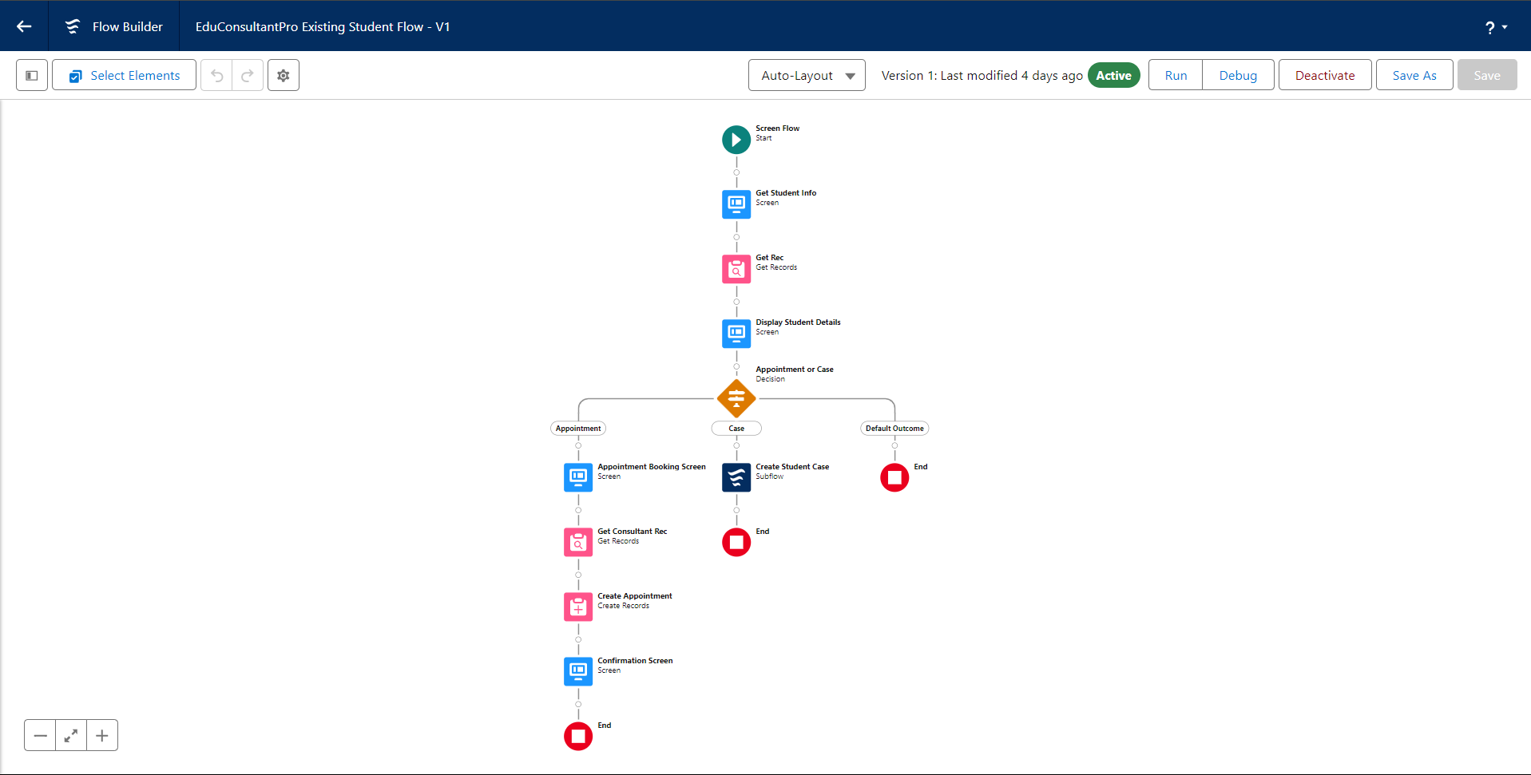

### *Create a Screen Flow to Combine all the flows at one place*

### 1. Create a Lightning App Page

1. **Open Salesforce** and navigate to the **App Builder**:
   1. Go to the **Setup** menu (gear icon).
   2. Enter "App Builder" in the Quick Find box and select **Lightning App Builder**.
2. **Create a New App Page**:
   1. Click **New**.
   2. Choose **App Page** and click **Next**.
   3. Enter the **Page Name** (e.g., "EduConsultPro Flow").
   4. Choose a **Page Template** (e.g., **One Region** or **Two Regions** depending on your preference).
   5. Click **Finish**.

### 2. Add and Configure Screen Elements

#### a. Add the Welcome Screen

1. **Drag a Screen Component** to the main panel.
   1. Label the screen as **Welcome Screen**.
2. **Add a Display Text Component**:
   1. From the left side panel, search for **Display Text**.
   2. Drag and drop it into the **Welcome Screen**.
   3. Label it **Success Message**.
3. **Enter the Text Content**:
   1. Paste the following text into the **Resource Picker** box:
4. Click **Done** to save the component.

#### b. Add the Existing or New Student Confirmation Screen

1. **Drag a Screen Component** to the main panel after the **Welcome Screen**.
   1. Label it **Existing or New Student Confirmation Screen**.
2. **Add a Radio Button Component**:
   1. From the left side panel, search for **Radio Buttons**.
   2. Drag and drop it into the **Existing or New Student Confirmation Screen**.
   3. Label it as **Are you an Existing Student**.
3. **Configure the Choices**:
   1. Click **Add Choice**.
   2. Type **Yes** in the input field and click **Create**.
   3. Repeat this process to create a **No** choice.
4. Click **Done** to save the component.

### 3. Add and Configure Decision Element

1. **Drag a Decision Element** to the main panel after the **Existing or New Student Confirmation Screen**.
   1. Label it **Decision 1**.
2. **Configure the Decision Element**:
   1. Under **Outcomes**, add a new outcome:
      1. Label it **If Existing Student**.
      2. Set the **Condition**:
         1. **Resource**: {!Are_you_an_Existing_Student}
         2. **Operator**: Equals
         3. **Value**: {!Yes}
   2. Click the **+** icon to add another outcome:
      1. Label it **If Not an Existing Student**.
      2. Set the **Condition**:
         1. **Resource**: {!Are_you_an_Existing_Student}
         2. **Operator**: Equals
         3. **Value**: {!No}
3. Click **Done** to save the decision element.

### 4. Add and Configure SubFlow Elements

#### a. Existing Student Flow

1. **Drag a SubFlow Element** to the main panel after the **Decision 1** element on the **If Existing Student** path.
   1. Search for **EduConsultantPro Existing Student Flow**.
   2. Label it **Existing Student Flow**.
2. Click **Done** to save the subflow element.

#### b. New Student Flow

1. **Drag another SubFlow Element** to the main panel after the **Decision 1** element on the **If Not an Existing Student** path.
   1. Search for **EduConsultantPro Student Flow**.
   2. Label it **New Student Flow**.
2. Click **Done** to save the subflow element.

### 5. Save and Finalize the Flow

1. **Save** the flow by clicking the **Save** button.
   1. Label the flow as **EduConsultPro Flow**.
2. Click **Activate** to make the flow available.

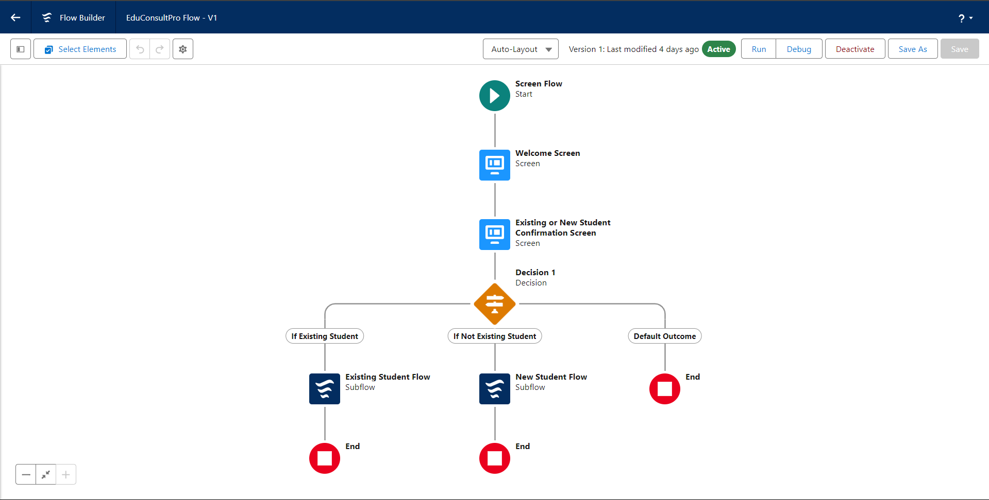

### *Create a lightning app page*

### 1. Create a New Home Page

1. **Open Salesforce** and navigate to **App Builder**:
   1. From **Setup**, enter **App Builder** in the Quick Find box and click **Lightning App Builder**.
2. **Create a New Page**:
   1. Click **New**.
   2. Select **Home Page** and click **Next**.
3. **Configure the Page**:
   1. **Page Name**: Enter **EduConsultPro Home Page**.
   2. **Page Template**: Choose the **Standard Home Page** template.
   3. Click **Finish**.

### 2. Add the Flow Component

1. **Add a Flow Component**:
   1. In the Lightning App Builder interface, drag the **Flow** component from the left panel to the top-right region of the page layout.
2. **Configure the Flow Component**:
   1. With the Flow component selected, use the right panel to search for and select the flow named **EduConsultantPro Flow**.
3. **Save the Page**:
   1. Click **Save** to save your changes.

### 3. Activate and Assign the Page

1. **Activate the Page**:
   1. Click **Activate** in the top-right corner of the Lightning App Builder.
2. **Assign the Page to Apps and Profiles**:
   1. Click **App and Profile** in the activation options.
   2. Click **Assign to Apps and Profiles**.
3. **Select the Sales App**:
   1. In the app assignment screen, select the **Sales** app.
   2. Click **Next**.
4. **Select Profiles**:
   1. Scroll down the list of profiles and select **System Administrator**.
   2. Click **Next**.
5. **Review the Assignment**:
   1. Review the assignment details and click **Save** to finalize the page assignment.

